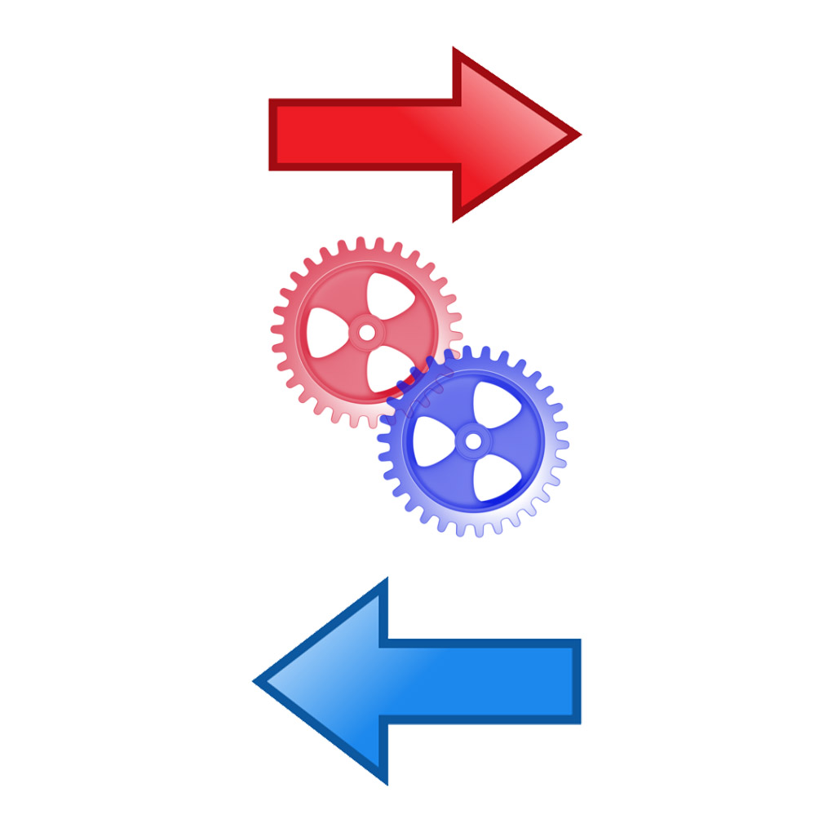

Decision made

Game ends

Fight results determined

Info grabbed from DOM

About

results

Decision made on damage output

Fighter Damage

Input

Fight Function Setup

Info grabbed from DOM

Var data created

Function Start